School Science Review Issue: October 2017 366
Reviews
Reviews published in School Science Review are the opinions of individual reviewers, and are not an official Association for Science Education (ASE) view or endorsement of the resource. Reviewers are selected to write reviews on the basis of their experience and interests. They are expected to draw attention to perceived weaknesses or limitations of a resource as well as its strengths. The reviews are written from the standpoint of someone seeing the materials for the first time and considering how they themselves would use them, or think colleagues would be likely to use them.
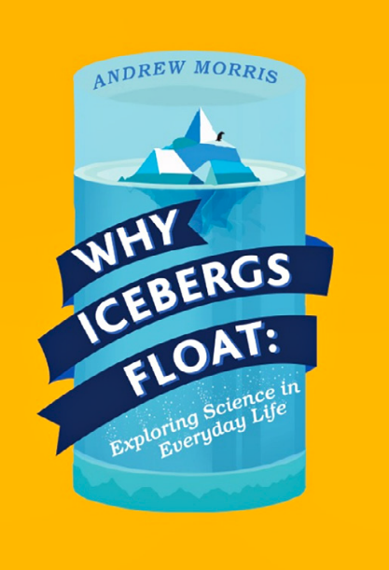

Why Icebergs Float: Exploring Science in Everyday Life
Andrew Morris London: UCL Press, 2016 224 pp. £15.00 (also available as an e-book or a free download from ucl.ac.uk/ucl-press) ISBN 978 1 911307 03 7
This book is aimed at those who are curious about science, but do not want to read a standard textbook. Instead, it aims to answer the sort of questions that occur in real-life situations, such as how we see, how the brain works or three-parent babies. It does this in the form of a discussion, with a group of people asking questions and making comments and explaining answers. In this format, you can dip into the book at any point and just start reading; you don’t need to read the chapters in any particular order.
The discussion format seemed a little contrived at times, but that does not detract from the quality of the explanation and the imaginative nature of the questioning. The use of language is very good. The book does use scientific language when necessary, but keeps the rest of the language at conversational level. The use of illustrations is very good, with clear pictures and diagrams used well in the explanations.
In answering the question that starts the chapter, new questions are sometimes encountered in the explanation. So one question leads to another and to how ideas link with everyday life. Asking questions is an important scientific skill and sometimes we can only understand something when we can find the language to ask the right questions; books like this can be really helpful in this respect.
This book is one of UCL’s open access books. This means that it can be downloaded as a free PDF from the UCL Press website. The commitment to making scientific works such as this freely available is very welcome. This book is very accessible and deserves to reach a wide audience.
Ann Reddecliffe

